Extended Detention Basin Maintenance Plan for

[[== Insert Project Name ==]]

[[== Insert Date =]]
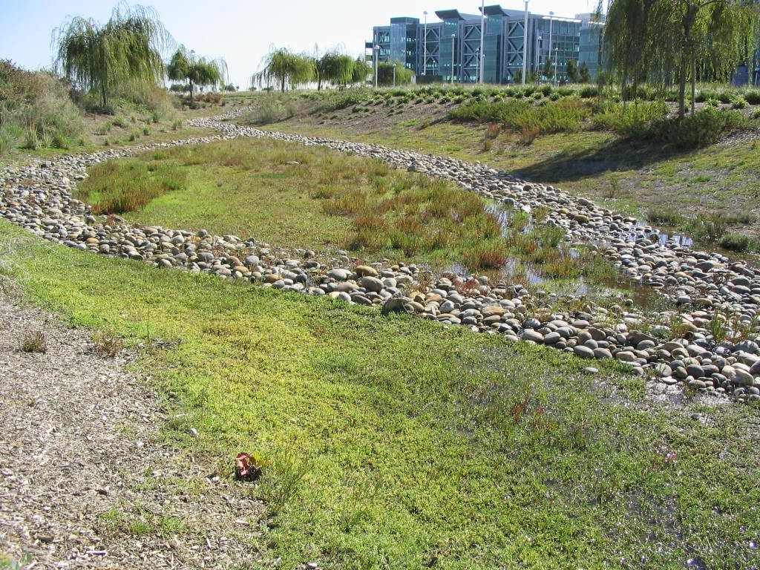
Vegetated swales are open, shallow channels with thick vegetation covering the side slopes and bottom that collect and slowly convey runoff to downstream discharge points.

Project Address and Cross Streets

Assessor’s Parcel No.:
Property Owner:
Phone No.:
Designated Contact: Phone N
Phone No.:
Mailing Address:

Extended detention ponds are basins whose outlets have been designed to detain the stormwater runoff from a water quality design storm for some minimum time (e.g., 48 hours) to allow particles and associated pollutants to settle.

The property contains [[== insert number ==]] extended detention basins, located as described below and as shown in the attached site plan.
- Extended Detention Basin No. 1 is located at [[== describe location ==]].
- [[== Add descriptions of other extended detention basins, if applicable. ==]]
- [[==Identify Extended Detention Basin(s) designed for Hydromodification Management (HM).]]

I. Routine Maintenance Activities
Primary maintenance activities include vegetation management and sediment removal, although mosquito abatement is a concern if the extended detention basin is designed to include permanent pools of standing water. Routine maintenance activities, and the frequency at which they will be conducted, are shown in Table 1.
Table 1
Routine Maintenance Activities for Extended Detention Basins
No. | Maintenance Task | Frequency of Task
1 | Conduct annual vegetation management during the summer, removing weeds and harvesting vegetation. Remove all grass cuttings and other green waste. | Once a year
2 | Trim vegetation at beginning and end of wet season to prevent establishment of woody vegetation, and for aesthetics and mosquito control. | Twice a year (spring and fall)
3 | Evaluate health of vegetation and remove and replace any dead or dying plants. Remove all green waste and dispose of properly. | Twice a year
4 | If turf grass is included in basin design, conduct regular mowing and remove all grass cuttings. Avoid producing ruts when mowing. | [[== insert frequency, if applicable ==]]
5 | Remove sediment from forebay when the sediment level reaches the level shown on the fixed vertical sediment marker and dispose of sediment properly. | As needed
6 | Remove accumulated sediment and regrade when the accumulated sediment volume exceeds 10% of basin volume and dispose of sediment properly. | Every 10 years, or as needed [[to maintain 2 in. clearance below low-flow orifice for HM design]]
7 | Remove accumulated trash and debris from the extended detention basin at the middle and end of the wet season and dispose of trash and debris properly. | Twice a year (January and April)
8 | Irrigate during dry weather. | [[== insert frequency ==]]
9 | Inspect extended detention basin using the attached inspection checklist. | Quarterly, or as needed

II. Prohibitions
The use of pesticides and quick release fertilizers shall be minimized, and the principles of integrated pest management (IPM) followed:
- Employ non-chemical controls (biological, physical and cultural controls) before using chemicals to treat a pest problem.
- Prune plants properly and at the appropriate time of year.
- Provide adequate irrigation for landscape plants. Do not over water.
- Limit fertilizer use unless soil testing indicates a deficiency. Slow-release or organic fertilizer is preferable. Check with municipality for specific requirements.
- Pest control should avoid harming non-target organisms, or negatively affecting air and water quality and public health. Apply chemical controls only when monitoring indicates that preventative and non-chemical methods are not keeping pests below acceptable levels. When pesticides are required, apply the least toxic and the least persistent pesticide that will provide adequate pest control. Do not apply pesticides on a prescheduled basis.
- Sweep up spilled fertilizer and pesticides. Do not wash away or bury such spills.
- Do not over apply pesticide. Spray only where the infestation exists. Follow the manufacturer’s instructions for mixing and applying materials.
- Only licensed, trained pesticide applicators shall apply pesticides.
- Apply pesticides at the appropriate time to maximize their effectiveness and minimize the likelihood of discharging pesticides into runoff. With the exception of pre-emergent pesticides, avoid application if rain is expected.
- Unwanted/unused pesticides shall be disposed as hazardous waste.
- Maintenance activities at the bottom of the extended detention basin shall not be performed with heavy equipment, which would compact the soil and limit infiltration.

Standing water shall not remain in the treatment measures for more than five days, to prevent mosquito generation. Should any mosquito issues arise, contact the San Mateo County Mosquito Abatement District (SMCMAD), as needed for assistance. Mosquito larvicides shall be applied only when absolutely necessary, as indicated by the SMCMAD, and then only by a licensed professional or contractor. Contact information for SMCMAD is provided below.

III. Mosquito Abatement Contact Information

San Mateo County Mosquito Abatement District
1351 Rollins Road
Burlingame,CA 94010
PH:(650) 344-8592
FAX: (650) 344-3843
Email: info@smcmad.org

IV. Inspections
The attached Extended Detention Basin Inspection and Maintenance Checklist shall be used to conduct inspections monthly (or as needed), identify needed maintenance, and record maintenance that is conducted.

Extended Detention Basin

Inspection and Maintenance Checklist

Property Address: Property Owner:

Treatment Measure No.: Date of Inspection: Type of Inspection:  Monthly  Pre-Wet Season
❑ After heavy runoff  End of Wet Season
Inspector(s):  Other:
Defect | Conditions When Maintenance Is Needed |  | Maintenance Needed? (Y/N) |  | Comments (Describe maintenance completed and if any needed maintenance was not conducted, note when it will be done.) | Results Expected When Maintenance Is Performed

General
Trash & Debris | - Trash and debris accumulated in basin.  - Visual evidence of dumping. |  |  |  |  | Trash and debris cleared from site and disposed of properly.
Poisonous Vegetation and noxious weeds | Poisonous or nuisance vegetation or noxious weeds, e.g., morning glory, English ivy, reed canary grass, Japanese knotweed, purple loosestrife, blackberry, Scotch broom, poison oak, stinging nettles, or devil’s club. |  |  |  |  | Use Integrated Pest Management techniques to control noxious weeds or invasive species.
Contaminants and Pollution | Any evidence of oil, gasoline, contaminants or other pollutants. |  |  |  |  | No contaminants or pollutants present.
Rodent Holes | If facility acts as a dam or berm, any evidence of rodent holes, or any evidence of water piping through dam or berm via rodent holes. |  |  |  |  | The design specifications are not compromised by holes.  Any rodent control activities are in accordance with applicable laws and do not affect any protected species.
Insects | Insects such as wasps and hornets interfere with maintenance activities. |  |  |  |  | Insects do not interfere with maintenance activities.
Tree/Brush Growth and Hazard Trees | - Growth does not allow maintenance access or interferes with maintenance activity.  - Dead, diseased, or dying trees. |  |  |  |  | - Trees do not hinder maintenance activities.  - Remove hazard trees as approved by the City.  (Use a certified Arborist to determine health of tree or removal requirements).
Drainage time | Standing water remains in basin more than five days. |  |  |  |  | Correct any circumstances that restrict the flow of water from the system. Restore drainage to design condition. If the problem cannot be corrected and problems with standing water recur, then mosquitoes should be controlled with larvicides, applied by a licensed pesticide applicator.
Outfall structure | Debris or silt build-up obstructs an outfall structure. |  |  |  |  | Remove debris and/or silt build-up and dispose of properly.

Side Slopes
Erosion | - Eroded over 2 in. deep where cause of damage is still present or where there is potential for continued erosion.  - Any erosion on a compacted berm embankment. |  |  |  |  | Cause of erosion is managed appropriately. Side slopes or berm are restored to design specifications, as needed.

Storage Area
Sediment | Accumulated sediment >10% of designed basin depth or affects inletting or outletting condition of the facility. |  |  |  |  | Sediment cleaned out to designed basin shape and depth; basin reseeded if necessary to control erosion. Sediment disposed of properly.
Liner (If Applicable) | Liner is visible and has more than three 1/4-inch holes in it. |  |  |  |  | Liner repaired or replaced. Liner is fully covered.
Emergency Overflow/ Spillway and Berms
Settlement | Berm settlement 4 inches lower than the design elevation. |  |  |  |  | Dike is built back to the design elevation.
Tree Growth | Tree growth on berms or emergency spillway >4 ft in height or covering more than 10% of spillway. |  |  |  |  | - Trees should be removed. If root system is small (base less than 4 inches) the root system may be left in place. Otherwise the roots should be removed and the berm restored.  - A civil engineer should be consulted for proper berm/spillway restoration.
Emergency Overflow/ Spillway | Rock is missing and soil is exposed at top of spillway or outside slope. |  |  |  |  | Rocks and pad depth are restored to design standards.
Debris Barriers (e.g., Trash Racks)
Trash and Debris | Trash or debris is plugging openings in the barrier. |  |  |  |  | Trash or debris is removed and disposed of properly.
Damaged/ Missing Bars | Bars are missing, loose, bent out of shape, or deteriorating due to excessive rust. |  |  |  |  | Bars are repaired or replaced to allow proper functioning of trash rack.
Inlet/Outlet Pipe | Debris barrier is missing or not attached to pipe. |  |  |  |  | Debris barrier is repaired or replaced to allow proper functioning of trash rack.

Fencing and Gates
Missing or broken parts | Any defect in or damage to the fence or gate that permits easy entry to a facility. |  |  |  |  | Fencing and gate are restored to design specifications.
Deteriorating Paint or Protective Coating | Part or parts that have a rusting or scaling condition that has affected structural adequacy. |  |  |  |  | Paint or protective coating is sufficient to protect structural adequacy of fence or gate.
Flow Duration Control Outlet (if included in design to meet Hydromodification Management Standard) [[==refer to any attachments with additional provisions==]]
Risers, orifices and screens | Any debris or clogging |  |  |  |  | Restore unobstructed flow through discharge structure; to meet original design; dispose of debris properly.
Miscellaneous
Miscellan-  ous | Any condition not covered above that needs attention to restore extended detention basin to design conditions. |  |  |  |  | Meets the design specifications.

